**MStar Highly Confidential**



**xZram Application Note**

# REVISION HISTORY

| Release version | Description | Writer | Date |
| --- | --- | --- | --- |
| Initial version |  | Kilroy.Tseng | 2013.4.18 |

1. **Intro**

Xzram is a ram-based block device, the basic operation logic are read and write. When xzram perform the write operation, it will compress the data and put them into memory and get it back when there is a read operation coming.

Write request:



Read request:



1. **Concept of External/Internal pool**

Traditionally, xzram use the memory that allocated from kernel, now xzram provide the user that configure the source of the memory from the external memory (which means we can use the memory co-buffer with some IP buffer). That is for sure that user should know every detail of the usage of the IP buffer.

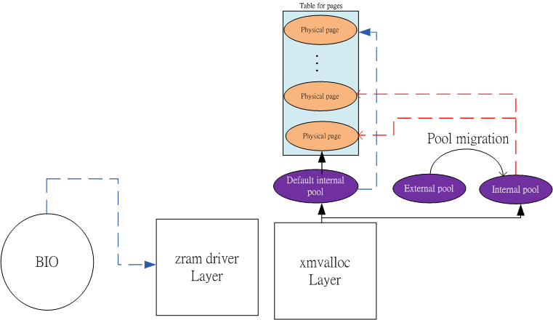

1. **Buildin xzram module:**
2. make menuconfig
3. Choosing xzram option:



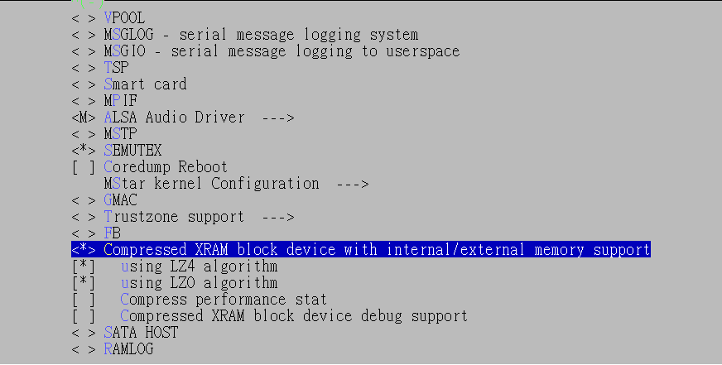

1. Then exit and make.
2. **How to use from user:**
3. Create node (Only perform once at the first time):
4. Check the major/minor number of xzram:



The red cycle above represent the major number and minor number for the blue one.

1. Using mknod to create a node:

mknod [node_name] [block] [major number] [minor number]



For example:

#mknod /Customer/xzram0 b 254 0

1. xZram module setting:

echo 3 > /proc/sys/vm/drop_caches **# clear the system cache**

echo 100 > /proc/sys/vm/swappiness **# make swap more aggressive**

echo $((50*1024*1024)) > /sys/block/xzram0/disksize **# setting up the size of xzram**

1. Open the external pool (optional, if you don’t set this step, all the memory xzram need will come from kernel memory):

echo 1 > /sys/block/xzram0/pool_set_id **# Set id 1 for configuring the external pool**

echo 1 > /sys/block/xzram0/pool_set_type **# Set 1 to designate the pool in ID1 is external**

echo 2684354560 > /sys/block/xzram0/pool_set_ba_start **# Set the Bus address of the external**

echo $((30*1024*1024)) > /sys/block/xzram0/pool_set_size **# Set the size of ID1 pool**

**disksize is the size for all xzram device, pool_set_size is a configuration that make partial memory coming from external pool even equal to disksize.**

**Remember the value must small than or equal to disksize from step2.**

echo 1 > /sys/block/xzram0/pool_set_activate **# Set pool with ID1 is online.**

1. Making swap on:

mkswap /Customer/xzram0 **# make the node that you create as a swap partition**

swapon -p 9999 /Customer/xzram0 **# swap on with priority 9999**

1. **How to migrate the pool on the run time:**

Note that you have to give the external pool back once you use it (Because it is IP buffer, IP will use the buffer ).

You can type below command to retrieve the info from all pool:

echo 1 > /sys/block/xzram0/xzram_info

Remember pool with ID0 is default internal that can not change the type.

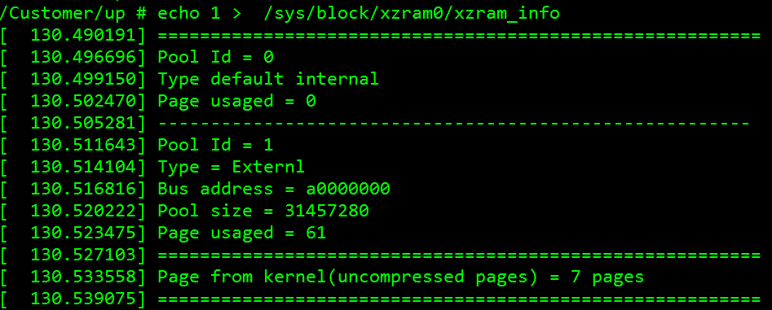

Every time you want to switch the pool type from one to another you should notice the migration flag, you can type below to get the info:

/Customer/up # cat /sys/block/xzram0/pool_set_migrate_stat

The pool_set_migrate_stat can be the value as below:

**#define MIGRATION_STAT_NO_JOB  0 // xzram is ready to migrate**

**#define MIGRATION_STAT_ONGO     1 // the migration is ongoing**

**#define MIGRATION_STAT_DONE      2 // the migration is done, waiting for clear**

**#define MIGRATION_STAT_FAIL         3 // the migration is fail, waiting for clear**

There is a particular rule that ensure every pool migration can be aware by user. This rule make user to know the timing of performing pool migration (In case HW IP interleave with external pool). So the flag “pool_set_migrate_stat” should be clear to 0 after every migration. Below is a example of migration progress:

echo 1 > /sys/block/xzram0/pool_set_id **# Config pool id to ID1**

echo 1 > /sys/block/xzram0/pool_set_migrate **# Do the pool migration to the external with ID1**

echo 0 > /sys/block/xzram0/pool_set_migrate_stat **# Clear the status of migrate_stat**

echo 0 > /sys/block/xzram0/pool_set_migrate **# Do the pool migration to the internal with ID1**

echo 0 > /sys/block/xzram0/pool_set_migrate_stat **# Clear the status**